Computing Server

🧠 What is a Computing Server?
# Source: Chatgpt (GPT-5-Mini) at [1/16/2026]
A Computing Server (also known as a Compute Server) is a powerful server system designed to process complex calculations and run computational workloads — rather than just store or serve files. These servers are used when processing power is more important than storage or networking.

⚙️ What Does a Computing Server Do?
# Source: Chatgpt (GPT-5-Mini) at [1/16/2026]
It provides CPU, RAM, and sometimes GPU resources for tasks such as:
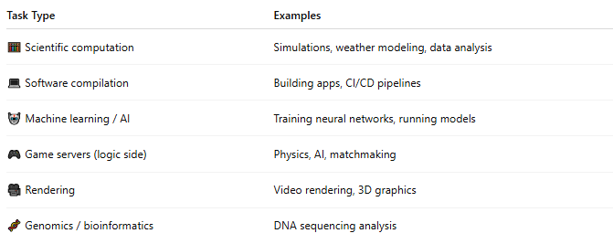
Task Type | Examples
🧮 Scientific computation | Simulations, weather modeling, data analysis
💻 Software compilation | Building apps, CI/CD pipelines
🤖 Machine learning / AI | Training neural networks, running models
🎮 Game servers (logic side) | Physics, AI, matchmaking
🎥 Rendering | Video rendering, 3D graphics
🧬 Genomics / bioinformatics | DNA sequencing analysis

🧱 Computing Server vs Other Servers
# Source: Chatgpt (GPT-5-Mini) at [1/16/2026]
Server Type | Main Purpose | Focus
File Server | Store and share files | Storage
Database Server | Manage structured data | Queries, I/O
Web Server | Serve web pages | HTTP performance
Computing Server | Run heavy CPU/GPU computations | Processing power

🔩 Key Components of a Computing Server
# Source: Chatgpt (GPT-5-Mini) at [1/16/2026]
Component | Role
🔥 High-core CPUs | For parallel computation & multitasking
⚡ Large RAM | To handle in-memory data and tasks
🎮 GPUs (optional) | For AI, rendering, or video-related workloads
🧊 Cooling Systems | Because high performance = more heat
🧱 Rack-Mountable | Often deployed in clusters in data centers

🧠 Where Are Computing Servers Used?
# Source: Chatgpt (GPT-5-Mini) at [1/16/2026]
Industry | Usage
🔬 Research Labs | Simulations, particle physics
🧠 AI Companies | Training deep learning models
🎥 Animation Studios | Rendering 3D animations
💼 Enterprises | Running virtual desktops, analytics
🌐 Cloud Platforms | Compute VMs (e.g., AWS EC2, Azure VM)

Computing Servers in a Data Center
# Source: Chatgpt (GPT-5-Mini) at [1/16/2026]
+-------------------------+
| Load Balancer |
+-----------+-------------+
|
+----------------------+----------------------+
| | |
+----------+ +------------+ +-------------+
| Web Server| --> | App Server | --> | Database |
+----------+ +------------+ | Server |
+-------------+
↓
+-----------------+
| COMPUTING SERVER |
| (e.g. GPU Node) |
+-----------------+
↓
Heavy processing tasks:
ML, AI training, rendering, simulation

- Web/App/DB Servers handle regular traffic.
- Computing servers are called when high-performance processing is needed.

AI / Machine Learning Pipeline with Compute Server
# Source: Chatgpt (GPT-5-Mini) at [1/16/2026]
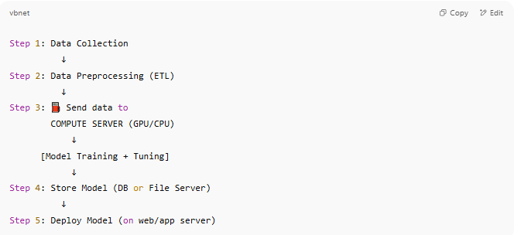
Step 1: Data Collection
↓
Step 2: Data Preprocessing (ETL)
↓
Step 3: ⛽ Send data to
COMPUTE SERVER (GPU/CPU)
↓
[Model Training + Tuning]
↓
Step 4: Store Model (DB or File Server)
↓
Step 5: Deploy Model (on web/app server)

🔹 Compute servers are used only for the “heavy-lifting” stage — training ML models, running simulations, or rendering media.

🔧 Example Use Case: 3D Animation Studio
# Source: Chatgpt (GPT-5-Mini) at [1/16/2026]
🎨 Designers → Create scenes
↓
🧠 Send to COMPUTING SERVER FARM
→ Renders frames with high CPU/GPU load
↓
🗄️ Output sent to File Server or Media Server
↓
🌐 Delivered to client or web

✅ Summary
# Source: Chatgpt (GPT-5-Mini) at [1/16/2026]
Role | Why Use Computing Server?
AI Model Training | Needs parallel GPU/CPU compute
Rendering | High resolution = intensive processing
Simulations (Science/Math) | Billions of calculations per second
Data Analytics | Process large datasets in-memory

✅ Summary
# Source: Chatgpt (GPT-5-Mini) at [1/16/2026]
Feature | Description
Definition | Server optimized for processing-heavy tasks
Focus | High CPU/GPU and memory performance
Used For | Science, AI, rendering, simulations
Not to Confuse With | File servers, database servers, or web servers

